






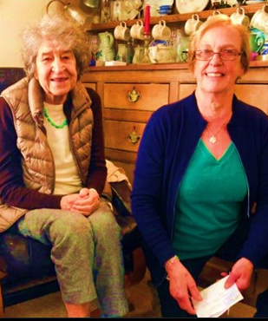
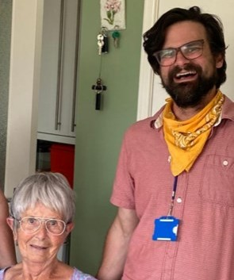

We are looking for volunteers across Somerset to work one-to-one with sight impaired people who live in the area.

Our befriending service volunteers visit regularly to provide companionship and support to people with sight impairment.
We offer full training and support, and pay all reasonable out of pocket expenses, including mileage.

If you would like to know more about joining our friendly team, please contact us on 01823 333818 or email: admin@somersetsight.org.uk

Head Office Address:
Northfield House, 51 Staplegrove Road, Taunton, Somerset, TA1 1DG. Tel: 01823 333 818 | www.somersetsight.org.uk
Registered charity number: 1154472 | Company number: 8432686

