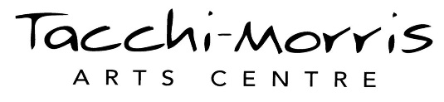
PRESS RELEASE

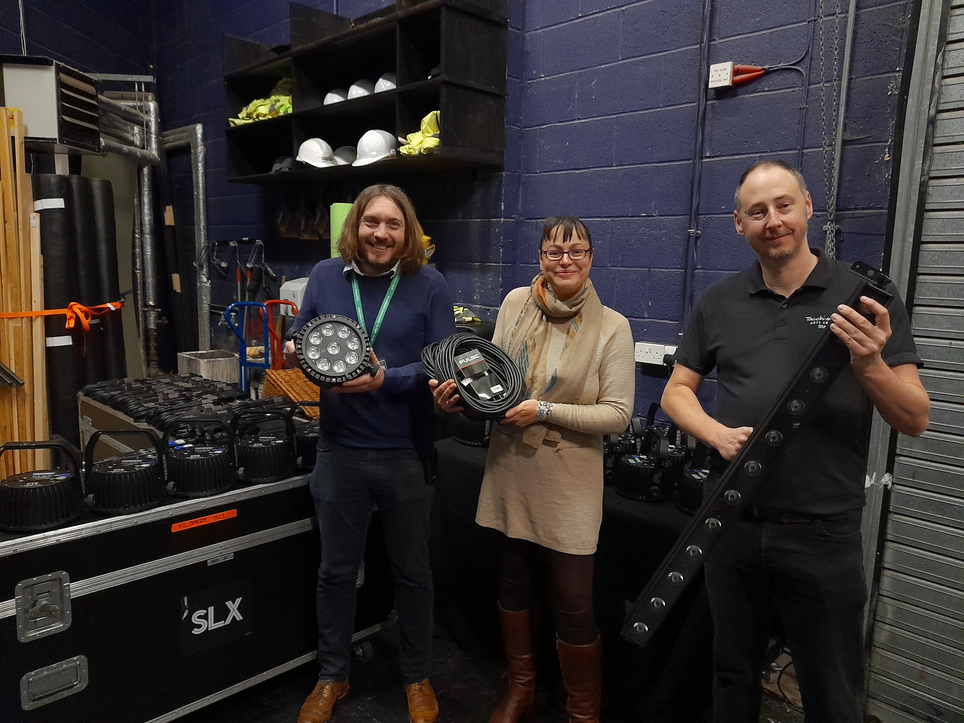
Lights, Climate, Action!

Tacchi-Morris Arts Centre are celebrating completing Stage 1 of a new LED Stage Lighting Switchover project. The generous support of West Monkton Parish Council, who have provided a grant of £14,500, means they have now switched 75% of their stage lighting to low-energy LED stage lights.
The project allowed 62 stage lights to be replaced by only 41 LED stage lights. The old lights had a combined total of 72,000 watts overall power consumption compared with the new LED lights which only use 4,500 watts in total. This 67,500 watts reduction, impacting over the course of a year, creates a significant reduction for the arts centre and is much more environmentally friendly.
The new LED lights also have technology that enables them to change colour when required. This feature means there is improved safety due to less working at height for the theatre’s Technical Team - who are often required to climb ladders to change colour gels.
The team at West Monkton Parish Council said, ‘We are exceptionally fortunate to have the Tacchi-Morris Arts Centre located in our Parish and as such, the Parish Council is pleased to be able to offer support where we feel it is required to benefit our community. Last year as part of the Parish Council's 'Build Back Better' initiative we supported the creation of the new coffee bar and the upgrade of the ground floor furniture upgrade. This year we are delighted to once again be giving our support but this time as part of our environmental initiative. Through the funds offered by West Monkton Parish Council, Andy and his team will be installing new low energy lights which will significantly reduce both the centre's Carbon Footprint and its running costs’.

Tacchi-Morris Arts Centre Director Andy Pulleyn said, ‘We are so grateful to the West Monkton Parish Council for their support with this project. Changing these lights to LED means we reduce our energy use and environmental impact, lower our running costs and improve health and safety for our team. It’s hard to think of a better project. Stage 2 of this project converts the remaining 25% of our stage lighting to LED but, because it involves changing and upgrading our infrastructure, it is significantly more expensive. We’re hoping to find more support from possible funders to help us finish the job and be 100% low-energy.’

ENDS (392 words)

IMAGES

Dropbox link: https://www.dropbox.com/sh/osffon4f4xr2ln2/AABgOB1xhkRQhkGzoELFv8qma?dl=0

SOCIAL MEDIA

Facebook: Tacchi-Morris Arts Centre
Twitter: @TMAC_Taunton

MEDIA CONTACTS

Andy Pulleyn
Centre Director, Tacchi-Morris Arts Centre
andy@tacchi-morris.com
01823 414143

Notes for editors

About Tacchi-Morris Arts Centre

Tacchi-Morris Arts Centre opened in 2000 as the result of a successful National Lottery bid and partnership funding from the Tacchi-Morris Trust. The centre aims to inspire all the community to get involved in the arts, be it as an audience member or taking part.

TMAC hosts a busy programme of theatre, dance, music and comedy as well as hosting a dynamic range of community classes. The programme is made up of professional and community work and includes a number of shows by local schools and colleges. In addition the centre exhibits approximately eight visual art exhibitions annually in the foyer gallery space.

Heathfield Community School and The SPACE put on many productions each year at TMAC including drama, dance, music and other events. TMAC’s work as part of Heathfield Community School and The SPACE continually demonstrates the value of the arts in developing skills and raising attainment, in challenging ideas and the world around us, in improving health and well-being and in building confidence and self-esteem.

Tacchi-Morris Arts Centre was developed through support from Kathleen Tacchi-Morris and continued support from the Tacchi-Morris Trust and Heathfield Community School. Core to the centre's existence is continuing the legacy of pacifism that echoed throughout Kathleen Tacchi-Morris’ work and life.

Visit the Tacchi-Morris Arts Centre website: www.tacchi-morris.com
Tacchi-Morris Arts Centre, School Road, Monkton Heathfield, Taunton, TA2 8PD

About West Monkton Parish Council
West Monkton Parish Council covers Bathpool, Monkton Heathfield and West Monkton and meets every month. In addition, there are working parties which pursue particular activities and report back to full council: meetings with SWT planners and developers: meetings to discuss reports and consultation reports. The Parish Council is a statutory consultee for various strategic and planning matters.
Additionally, the Parish Council has worked in conjunction with Cheddon Fitzpaine Parish Council to deliver a Neighbourhood Plan for the area. Members of the public are welcome to attend the Parish Council meetings, and volunteers to help get engaged in community activities are always welcome.

The Parish Council has developed a vision and objectives, available here: West Monkton Parish Council Vision and Objectives

A full list of what the Parish Council does and the responsibilities / functions of the District and County Council is available here: Council Functions

